Academic CV
Rasha Afify Latest update: October, 2024

Personal:

Name: | Rasha Mohammed Elsyed Afify | 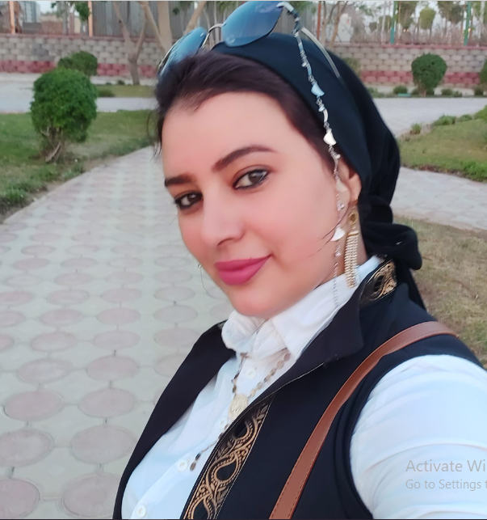
Position: | Assistant Professor (Lecturer)
Affiliation: | Department of Mechanical Engineering, Faculty of Engineering at Shoubra, Benha University.
Address: | Flat No. 21, Building No. 4141, Zahraa Madent Nasr, Cairo.
Born: | 1st July 1982 (Kalubia- Egypt)
Marital Status: | Married
Telephone: | 01015300345
E-mail: | Rash.Ali@feng.bu.edu.eg  Remasm7md33@gmail.com
Home page: | http://www.bu.edu.eg
Google scholar: | https://scholar.google.com/citations?user=SMbl3rcAAAAJ&hl=en
ORCID: https://orcid.org/0009-0009-4836-320X

Education:

2012-2016 | Ph.D. “Effect of Friction Stir Spot Welding Process Parameters on the Mechanical, Dynamic and Corrosion Behaviour of Aluminum Alloys.”  Mechanical Engineering Department (MED), Shoubra Fuculty-Benha University of Benha.  Supervisors:  Prof. Dr. Tarek Khalifa  Prof. Dr. Prof. Dr. Saber.M. Abd-Rabbo  Prof. Dr. Prof. Dr. Tamer.S. Mahmoud.
2006-2011 | M.Sc. “CONTROLLING OF ELECTROCHEMICAL MACHINING PROCESS.  Supervisors:  Prof. Dr. Saber M. Abd Rabbo, Head of Metals Technology, Department, ‎Central Metallurgical R&D Institute (CMRDI), Egypt.  Prof. Dr. Tamer S. Mahmoudud‎‎, Benha University, Egypt.‎  Dr. Raouf T. Fahmy, Benha University, Egypt.
1999-2004 | BSc. Mechanical Engineering (Production and Design Section). The General Grade is Very Good with Honors. Mechanical Engineering Department, Faculty of Engineering at Shoubra, Benha University, Egypt.
Research Area:

- Non Conventional machining process
- Welding and joining
- Mechanical Vibration System
- Advanced functional metallic materials (Design and Processing).
- Nanocomposites such as Aluminum Alloys.
- Steel processing and heat treatment

Publications:
- Afify, R. M., Mahmoud, T. S., Abd-Rabbo, S. M., & Khalifa, T. A. (2015). On the microstructural and mechanical characteristics of friction stir spot welded AA1050-O aluminum alloys. MSAIJ, 13(7), 226-236.
- Mohammad, J. H. A., Afify, R. M., Mansour, E. H., & Gaafer, A. M. (2019). Effect of heat treatment of steel AISI X 210 Cr 12 on surface roughness quality during turning operation. Engineering Research Journal, 1(39), 6-11.
- Samir Mahmoud, T., Hamza Mansour, E., Afify, M., & Mohamed Hasona, K. (2020). Corrosionrate prediction model using Box-Cox transformation of friction stir processed Al-Si alloy. Engineering Research Journal (Shoubra), 43(1), 1-6.
- Samir Mahmoud, T., Hamza Mansour, E., Mohamed Afify, R., & Mohamed Hasona, K. (2020). Statistical Analysis of Statistical Analysis of Statistical Analysis of Hardness and Wear Behaviour of Friction Stir Processed Cast Al-Si Alloy. Engineering Research Journal (Shoubra), 43(1), 7-12.
- K Soliman, F., S Habib, S., & M Afify, R. (2021). Wear and friction behavior of epoxy/BN nanocomposites. Engineering Research Journal (Shoubra), 47(1), 38-44.
- F Sakr, M., M Afify, R., M Gaafer, A., & H Mansour, E. (2021). Statistical Analysis of Friction Stir Welding Parameters. Engineering Research Journal (Shoubra), 48(1), 1-7.
- Hasona, K. M., Afify, R. M., Mansour, E. S. H., Gaafer, A. M., Mahmoud, T. S., & Mosleh, A. O. (2021). Effect of FSP on mechanical properties, wear and corrosion behavior of A356 Al alloy. Surface Topography: Metrology and Properties, 9(2), 025004.
- Albarbary, Y. E., Afify, R., Mansour, E. H., Mahmoud, T. S., & Khedr, M. (2022). The effect of pre-drilling on the characteristics of friction drilled A356 cast aluminum alloy. Journal of Manufacturing Processes, 82, 646-656.
- Rasha Afify, Abdel-Aleem, H. A., & Gamil, M. (2024). INVESTIGATING TIG ARC WELDMENTS FOR AUSTENITIC STAINLESS STEEL 304 AND 304L: A MECHANICAL AND METALLURGICAL ANALYSIS. Engineering Research Journal (Shoubra), 53(1), 181-188.
- Afify, R., & Gamil, M. (2024). EFFECT OF WELDING SETTINGS ON MECHANICAL CHARACTERISTICS, MICROSTRUCTURAL FEATURES, AND CORROSION PERFORMANCE IN FRICTION STIR WELDING OF DISSIMILAR AA6082-T6/7075-T6 JOINTS. Journal of Al-Azhar University Engineering Sector, 19(71), 677-697.
- Afify, Rasha. "Investigation of Friction Stir Spot-Welded Dissimilar Aluminum and Steel Metallic Lap Joints through Experimental Approaches." Journal of Al-Azhar University Engineering Sector 19, no. 73 (2024): 1209-1226.

- Ahmed Abdalkareem, Rasha Afify, Nadia Hamzawy, Tamer S. Mahmoud and Mahmoud Khedr. Thermal Management of Friction-Drilled A356 Aluminum Alloy: A Study of Preheating and Drilling Parameters. J. Manuf. Mater. Process. 2024, 8, 251.

Professional Experiences:

2020 – Now  2018 - Now  2016 - Now | Assistant Professor, Construction Sites Engineering & Management Engineering department at Shoubra, Benha University, Egypt  Assistant Professor, Industrial Department, Faculty of Engineering at Shoubra, Benha University, Egypt  Assistant Professor, Mechanical Engineering Department, Faculty of Engineering at Shoubra, Benha University, Egypt.
2016 - 2012 | Lecturer, Mechanical Engineering Department, Faculty of Engineering at Shoubra, Benha University, Egypt may visit to Tabata Lab. I achieved
2016- 2012 | Ph.D student, Production and Design Department – Shoubra Fuculty of Engineering- Benha University
2012 - 2006 | Research and teaching assistant, Mechanical Engineering Department, Faculty of Engineering at Shoubra, Benha University, Egypt.
2006 – 2004 | teaching assistant, Mechanical Engineering Department, Modern Academy for Engineering.
Teaching Experience for Undergraduates:

- SolidWorks | - Engineering Drawing and Projection
- AutoCAD | - Theory of Machines
- Mechanics (Statics + Dynamics) | - Manufacturing Processes Lab
- Health and Safty Managment | - Materials Science Lab
- Manufacturing Processes | - Mechanical Vibrations
- Fundamentals of Materials Science | - Mechanical Design (2)
- Strength of Materials | - Ergonomic
- Mechanical Design (1) | - Graduation Project
- Fault Daignosis Using vibration
- Computer Application in Design
- Powder Metullurgy
Teaching Experience for Postgraduates:

- Manufacturing Design
- Composite Material

Graduation Projects:

Year | Project Name
2021-2022  Benha University  Faculty of Engineering at Shoubra | - Studying the effect of welding parameters of TIG welding on stainless steel 304
2022-2023  Benha University  Faculty of Engineering at Shoubra | - Dissimilar Friction Stir Welding of AA7075-T6 and 6082 –T6
2023-2024  Benha University  Faculty of Engineering at Shoubra | - Friction Stir Spot (FSSW) of dissimilar material 1006 carbon steel and Aluminum alloy 7075
Languages:

Arabic The mother language
English TOEFL score 87 IBT (580 paper-based test) on 2013

